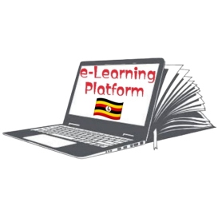**FRESH TEACHER'S E-LIBRARY**

**BEGINNING OF TERM III EXAMINATION 2023**

**MIDDLE CLASS: (4 – 5 YEARS)**

**LEARNING AREA 2: LANGUAGE DEVELOPMENT I**

**My name is: ……………………………………………………………….**

**My School is: …………………………………….………………………..**

**I am in: ………………………………..…………………………….…………………..**

1. **Colour the picture for the letter.**

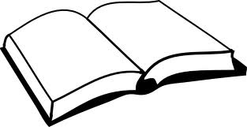b

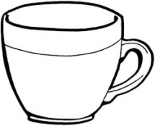

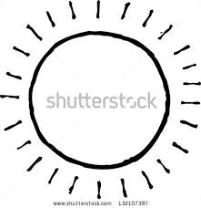

s

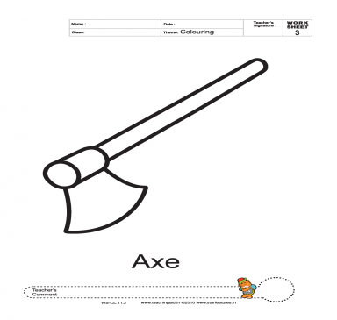

t

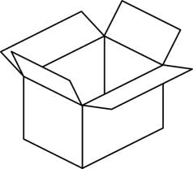

a

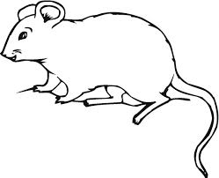C

1. **Tick the correct word.**

chair ($√$) airch chrai

xob box oxb

bed deb ebd

ucp pcu cup

1. 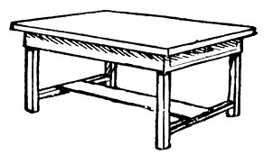**Match the same and draw.**

pot table ________

tin bell ________

bag tin ________

table pot ________

bell bag ________

1. **Write the sentence for the picture.**

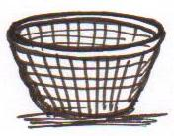

It is a basket.

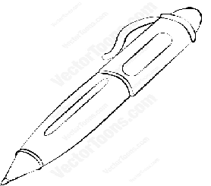

_______________________



________________________



________________________

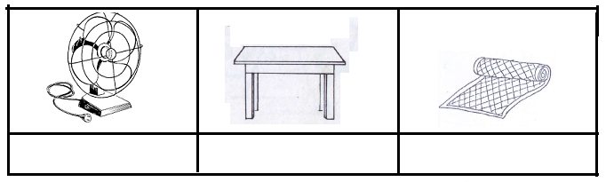

_________________________

1. **Match, name and colour.**

___________

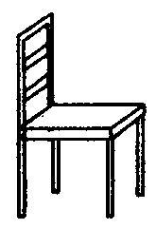

___________



___________





___________



__________

(pencil, tin, chair, table, book)

**End**